**Connecting and Express JS app with MongoDB**

1) Navigate to the knote-js app folder

* **cd knote-js/01**

2) Create a Docker file inside the folder with the following contents

**FROM node:12.0-slim**

**RUN mkdir /test**

**WORKDIR /test**

**COPY . /test/**

**RUN npm install**

**CMD [ "node", "index.js" ]**

* This function keeps trying to connect to a MongoDB database at the given URL until the connection succeeds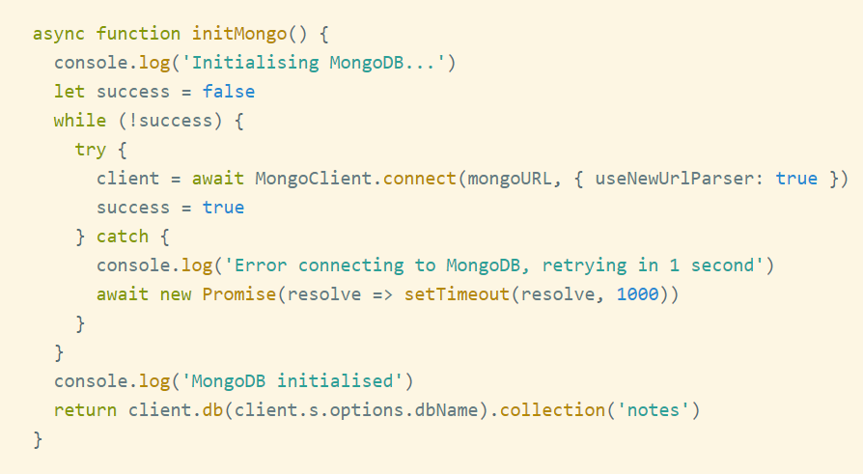

3) Hence Deploy your app with a mongo dB database

Before creating the db, lets create a separate network.

* **docker network create knote**

4) Now run a mongodb docker container inside the created network.

* **docker run --name=mongo-demo --network=knote mongo**

5) Check if your container has created

* **docker ps**
* **docker logs mongo-demo**

6) Now run the Knote app with the docker image that was build

* **docker run --name=knote --network=knote -p 9011:3000 -e MONGO_URL=mongodb://mongo-demo:27017/dev knote**

Open your browser and hit <http://localhost:9011> and you can see your app running.